KS2 Numbers and Body Parts
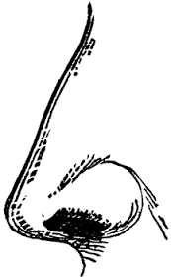
Cut out the picture, stick them in your book and write a sentence using the grid below to help you.
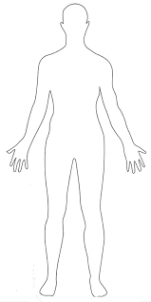

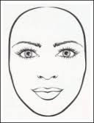
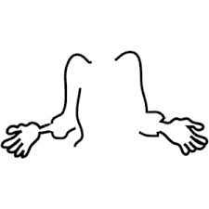
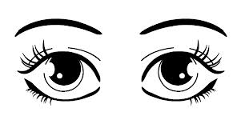

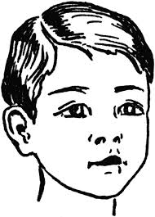
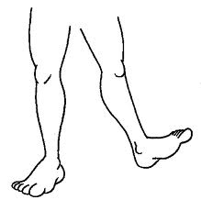
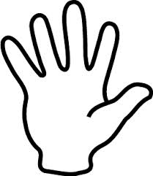

I have | one  two  ten | face.  eyes.  fingers.  head.  arms.
I have | one  two  ten | legs.  body.  nose.

I have | one  two  ten | face  eyes  fingers  head  arms  legs  body  nose | and | one  two  ten | face.  eyes.  fingers.  head.  arms.  legs.  body.  nose.

