KS3 English
Look at the picture and describe the scene.

Think about what you could see, hear, smell and taste if you were there.

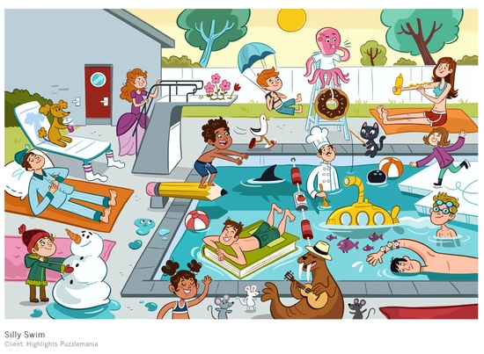
I can | see  hear  smell  taste | a snow man.  the children.  the sun cream.  flowers.  carrot.  water.

Modelled sentences
I can see a ………..
I can see the ………….. and smell the ……………….

