Science KS2

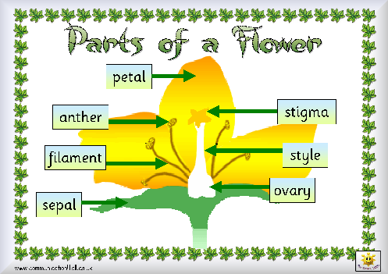
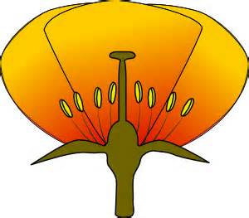

Substitution table
The | petal  anther  filament  sepal  stigma  style  ovary | is | white  yellow  green  grown

Modelled sentences
The …………….. is ………………..
The ……………………. Is …………………………….. but the ………………… is ………….
Both the ………………. and ………………. are………………………………

