P.E. KS4
Movement | Plane | Joints | Sporting example
Abduction | Sagittal | Shoulder
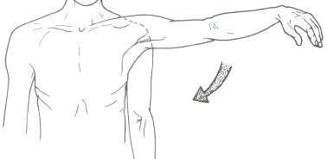  Adduction | Frontal
Rotation | Traverse | Hip
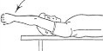  Flexion |  | Knee | follow through when kicking a ball
Extension |  | Elbow
Plantar F. |  | Ankle
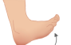  Dorsiflexion |  | Wrist

Modelled Sentences
………………………………………………… is a type of movement that occurs at the ………………………… plane.

An example would be ……………………………………. joint.

