History
Describe what you see
The Tsar
1)
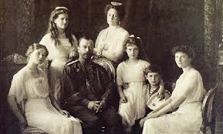

Substitution table
In the picture I can see | the Tsar.  four princesses.  a prince  crowns.  dresses.  hair.

2)
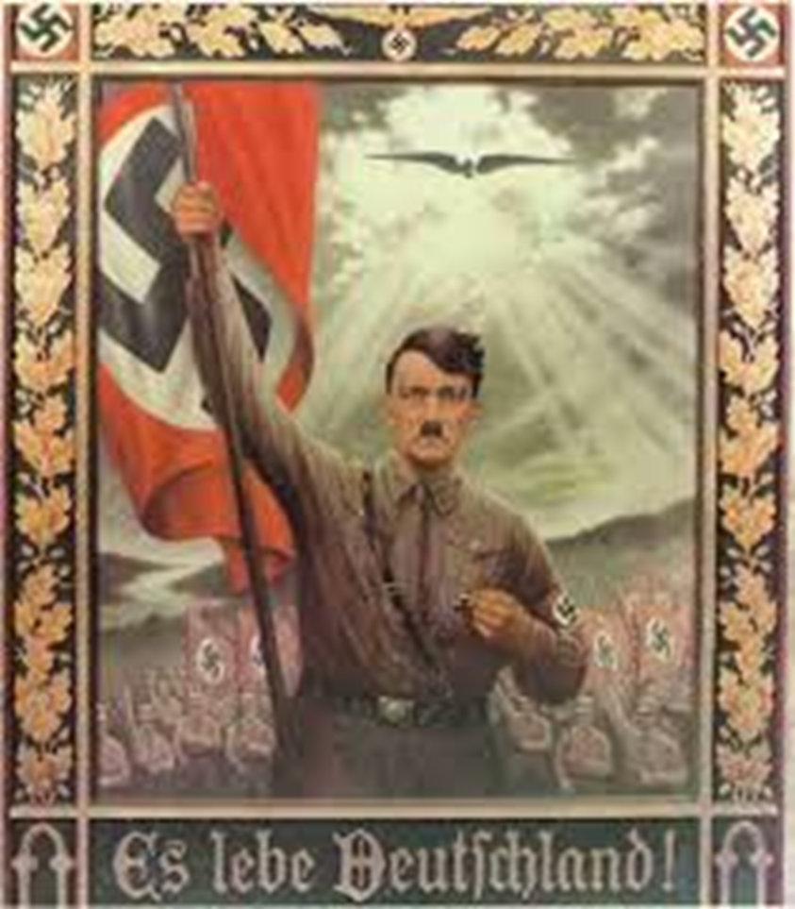
Describe what you see.

badge

Substitution table
In the picture I can see | a  an | badge.  eagle  flag  Hitler  sun.  people.

3)
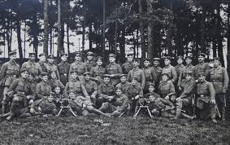
hat

Substitution table
In the picture I can see | a  an | hat.  tree.  arm.  leg.  uniform.  soldier.

