History KS3-4
There is a powerful eagle.

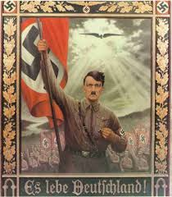

Add the labels to the picture.
- The sun is shining on Hitler.
- There is a Nazi flag.
- There are lots of people supporting.
- Hitler is leading the way.
- There is a powerful eagle.


because there is a powerful eagle.
because…
because…

This poster shows support for Hitler…
Another reason is…

because…
because…

This poster shows support for Hitler because there is a powerful eagle.

Another reason is because there is ………..

A third reason this poster shows support for Hitler is ……

A further reason is because …………..

Finally, this poster shows support for Hitler because ……..

