History KS2
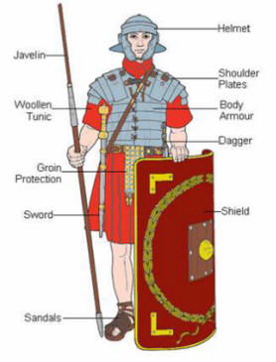

The solder | is | holding  wearing | a javelin.  a helmet.  sandals.  shoulder plates.  woollen tunic.  shield.  sword.  groin protection.  dagger.  body armour.

