English KS3
- Supporting creative writing

Label these pictures with as many words as you can think of:
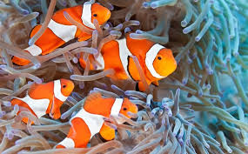
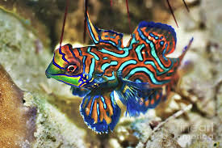

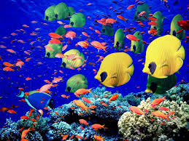
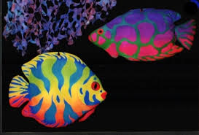

This fish | has  is  looks | stripes.  spots.  patterns.  colourful.

Substitution table
This fish | has | stripes  spots  patches  patterns | which are  which is  that are | colourful.  wavy.  pointy.  square.  like corals.

- School life
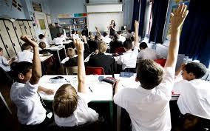
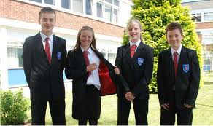
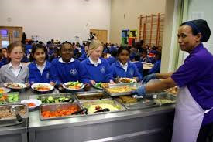


In school | we have  there are  we wear | School uniform.  Lessons.  School dinner.  Prefects.

In school | we have  there are  we wear | school uniform  lessons  school dinner  prefects | which are  who are | blue and black.  delicious.  helpful.  interesting.
Substitution table

