English KS2
Action verbs about Miss Trunchbull
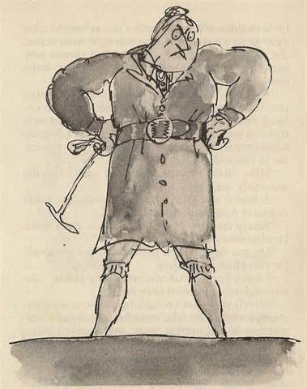

stomps pushes shouts
stares poses commands

Modelling Sentences
Miss Trunchbull …….
Miss Trunchbull …….. and …………………….
Miss Trunchbull often/sometimes/ often ……….

