English KS2

The boy  Grandpa  Grandma | is  was | sad.  happy.  grumpy.  upset.  moody.  crying.  excited.  worried.  scared.
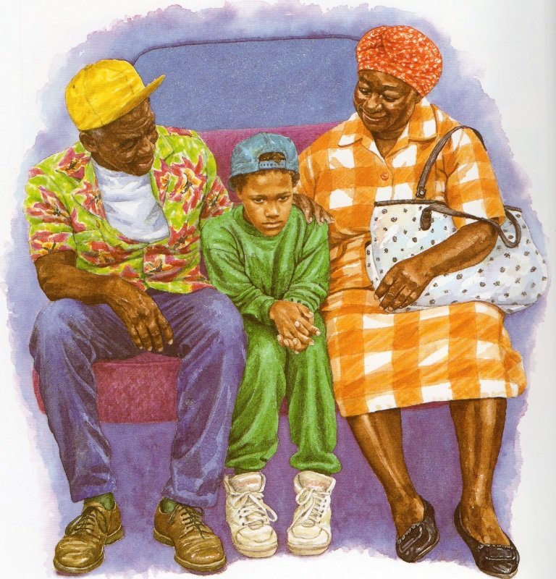
Substitution Tables

Example: The boy was crying

Write 4 sentences in your book.

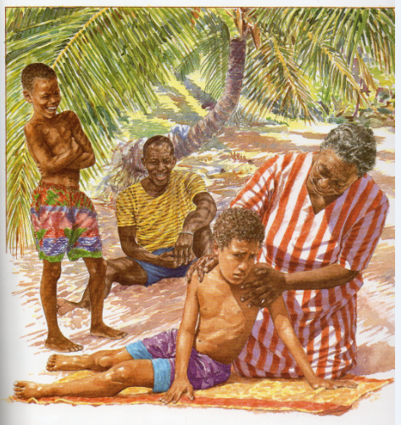

grandma

Gregory

Example: Grandma was very kind.
Grandma  Gregory | is  was | very  so  quite  a little | upset.  sad.  kind.  caring.

Gregory’s shorts  The tree  Grandma’s dress  Grandma’s hair  Grandpa’s T-shirt | is  are | green.  red.  blue.  grey.  purple.

