Food KS1

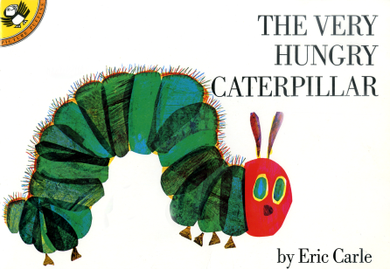 The Very Hungry Caterpillar

Day of the week | Fruit | Number of fruits
Monday
Tuesday
Wednesday
Thursday
Friday

On | Friday  Monday  Thursday  Wednesday  Tuesday | he ate | three (3)  five (5)  one (1)  four (4)  two (2) | 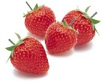  strawberries  apple  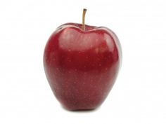  oranges  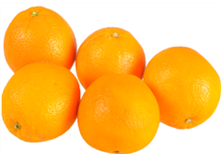  pears  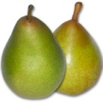  plums  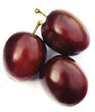

Modelled sentences

On ______________________ he ate _____________ __________________________ .

