Science and Design & Technology KS3
Waterproof | Not waterproof
rubber  plastic  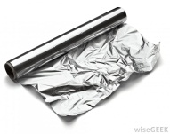  tin foil  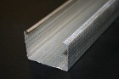  glass  metal | paper  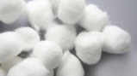  cotton wool  wood  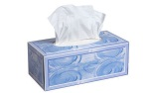  tissue

Substitution table
Rubber  Plastic  Tin foil  Glass  Paper  Cotton wool  Metal  Wood  Tissue | is  is not | waterproof.  waterproof.
Paper is not waterproof.
Hard | Soft
wood  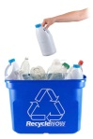  metal  plastic | wool    fabric  velvet

Substitution table
Wood  Metal  Plastic  Wool  Fabric  Velvet | is | hard.  soft.
Wood is hard.

