Science KS2
gaseous | rocky
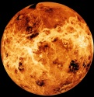  Venus  Mercury  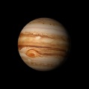  Jupiter  Uranus | 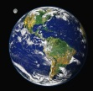  Earth  Mars  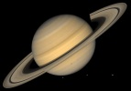  Saturn  Neptune

Substitution table

Saturn  Uranus  Jupiter  Mars  Venus  Neptune  Earth  Mercury | is | gaseous.  rocky.
Modelled sentences
Mars is rocky.

