**Maths KS4-5**

Copy and complete the table by placing each item in the correct column:

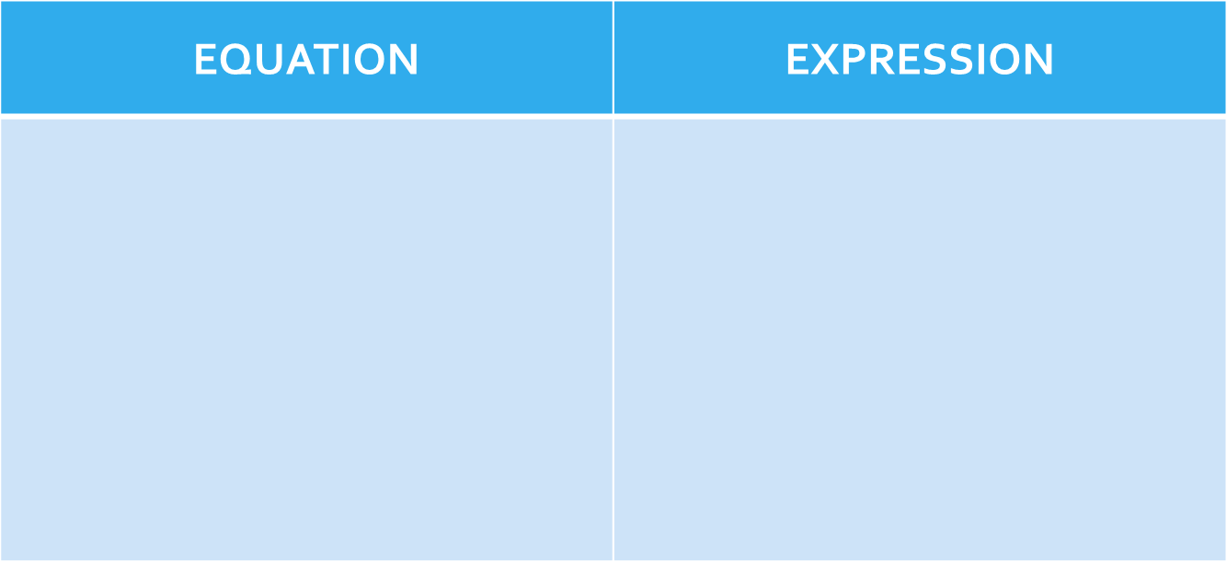



6y - 7 = 3

2a + 3 = 4a - 7

25 – a = 2

y + 7y = 40

6c + 17

6y - 7

8q - 5

12c + 8b

2 + k + f

2 + h = 4

9u + 7

|  |  |  |
| --- | --- | --- |
| 8q – 5  6y - 7 = 3  25 – a = 2  6c + 17  2 + k + f  2 + h = 4  12c + 8b  y + 7y = 40  9u + 7  6y – 7  2a + 3 = 4a – 7 | is an | equation.  expression. |

Modelled sentences

……………………….. is an equation.

……………………….. is an equation but ……………………….. is an expression.